A CIRCULAR NORTH OF TOWN
Distance:- 1 ½ miles
Time:- 1 hour
Description:- Town & Country paths. A few gentle slopes, one steep descent
Start/End:- Market Square
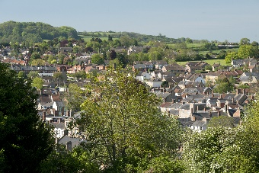
- Facing the Town Hall follow the left side of the hall & take the left
turn into Abbey Street.
- Continue along Abbey Street into Pople’s Well
- After passing Victoria Square on the right turn into lane signed
Broadshard (Westover Lane)
- Follow the footpath through the rambler gate. Straight ahead across the
field and through a second rambler gate. Turn left, keeping under hedge
left to gateway.
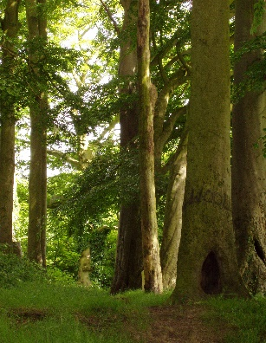
- Pass through gateway and right onto cart track. After 50 yards turn right along footpath. At the bottom of the slope bear left and through the rambler gate (ignore gate on right). Walk on down the slope to bottom left hand corner the field.
- Walk through the rambler gate and down the steps to footpath behind houses. Turn right along metalled driveway to main road (Broadshard A356). Very busy main road – please take care.
- Turn left and follow pavement towards junction signed Merriott.
- Before reaching junction cross over main road at take cart track on the right. (Longstrings Lane)
- Follow the track until it bears sharp left, Do not turn left but take the footpath to the right behind the houses on to metalled road (Aspen Way). Turn right.
- Take the first left onto Maple Drive to main road (Ashlands Road). Cross Main Road and turn right past Beechwood Drive and take the footpath sloping up to the left. (Brickyard Lane)
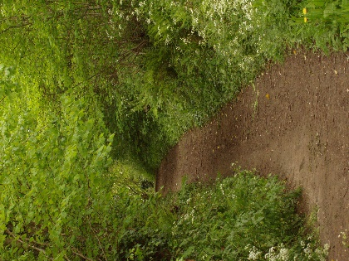
- Follow path, ignoring first pathway sloping back to the left. Continue approxiamately 100 yards and take the footpath sloping upwards onto Bincombe Hill.
- Keep under the hedge to the right and continue along footpath.
- Walk through the gap in the beech trees and out onto the meadow overlooking Crewkerne Town.
- Facing the town, walk to the bottom of the meadow, down the steps and through the kissing gate.
- Continue down the steep pathway to Bincombe Lane. Turn right and out into Market Square.

