CREWKERNE BLUE PLAQUES TRAIL
Distance:- 1 ¼ miles
Time:- 1 ¼ hours
Description:- An easy walk to visit all the Blue Plaque buildings in Crewkerne
Start/End:- Market Square
As part of Crewkerne’s celebration of the Milennium, the Crewkerne Civic Society, aided by a lottery grant, decided to set up a series of blue plaques to interpret & commemorate buildings in the town which had special qualities, or historical associations. Eighteen plaques were installed at this time and subsequently an extra one was added in 2015. This walk will take you past them all.
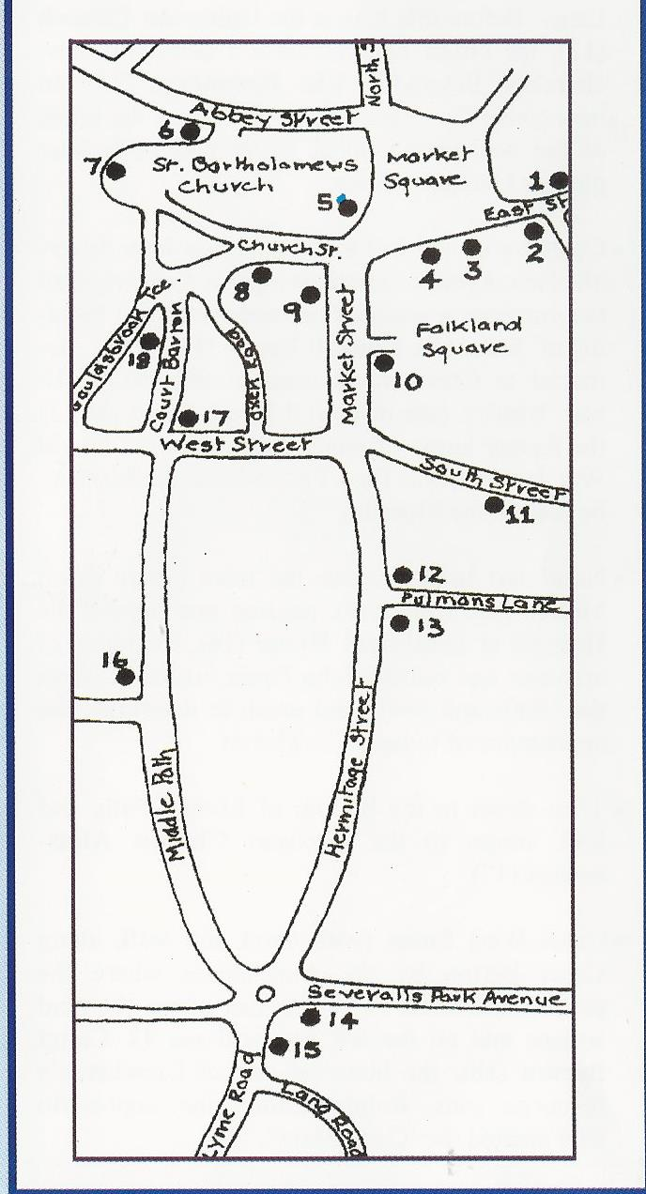
Before leaving the Town Hall to visit East Street take a look at the Ham Stone Plaque affixed to the Town Hall to the left of the double red doors. This commemorates the visit of Her Majesty the Queen & His Royal Highness Prince Philip during their Diamond Jubilee Tour of the United Kingdom. This handsome plaque was carved by local lad, Chris Berridge, who was a winner of the Team UK (Stonemasonry) Gold Medal at Worldskills London 2011.
- From the Town Hall in Market Square & cross over towards the George Hotel, turning left into East Street. About 100 yards on the opposite side is Merefield House (1), an impressive town mansion. The ‘gazebo’ one of its best features can be seen from Orchard Lane looking upwards towards Bincombe Hill.

- Turn back along East Street & on the left is Candle Cottage (2), a Mediaeval house with Stringfellow connections. Further along is the White Hart (3) a fine mediaeval building and the oldest of Crewkerne’s surviving inns.
- Next door to the White Hart is Crewkerne Museum & Heritage Centre (open Wednesday to Saturday in the Season).

- The George Hotel (4), an important Georgian coaching inn connected with the early development of the postal services.
- Cross back to the Town Hall, where you will find the Local Information Centre, and go left up the west side of Market square to Oscar’s Wine Bar (5) a building with some remarkable features including 12th Century cellars & good Mediaeval woodwork

- Turn left into Abbey Street & proceed to the commercial buildings on the left at No. 3 (Now renamed Tailor’s Yard). Originally a sail cloth factory it became the Bonsoir factory and offices. These buildings have been renovated and converted into apartments. Take note of the Georgian House designed by local architect John Patch. A blue plaque was added in 2015.
- Further along Abbey Street is the Church Hall (6) an attractive 17th Century building which used to be the Grammar School. From here enter the Churchyard, keeping right for a wonderful view of St Bartholomew’s Church. Continue around the churchyard & spot the plaque on the wall commemorating The Abbey (7) which lies behind. The current 19th Century building is on the site of one of the Mediaeval clergy houses. There never was an Abbey in Abbey Street!

- Follow the path round and down the steps into Church Street at look at number 9 (8), the first of a number of fine mid 18th Centrury houses on the south side of the street.

- Now turn into Market Street and admire the classical building of NatWest Bank (9), an early example of a purpose built bank.

- Continue along Market Street & cross to Falkland Square. On the right is 17 Market Street (10), a grand 18th Century town house, the former home of the Blake family.

- From here, continue along Market Street, into South Street crossing the entrances to the car park. Shortly, on the right hand side is the site of Christ Church (11), a demolished Victorian Anglican Church, commemorated on its surviving churchyard wall.

- Walking back towards the town centre turn into Hermitage Street, and continue to the Junction with Pulman’s Lane where you will find the Unitarian Church (12) the oldest of Crewkerne’s non-conformist churches. Just beyond is the Hermitage (13), an impressive Georgian house once the home of the well- known local writer & newspaper pioneer.

- Continue up the hill to the junction with Severalls Park Avenue, where on a pillar to the right of the entrance a plaque commemorates the building of Severalls Council Estate (14), a war memorial to Crewkerne’s dead in the 1914-18 war. Nearby at 3 Lyme Road (15) is the home of our much decorated First World War hero, Private Fred Fox, whose medals may be seen in the museum.

- Cross over the road to Middle Path. Just beyond the hospital is Southfield House (16) the home of the architect & builder John Patch whose work in the 1830s & 40s did much to determine the appearance of today’s Crewkerne.

- At the bottom of Middle Path look across to the Jacobean Chubbs Almshouses (17)

- Cross West Street with care & walk along Court Barton by the Almshouses where the plaque is situated. A little further along the road on the left is 12 Court Barton (19), the home of Ralph Reader, the impresario who created the ‘Gang Show’.
This is the last plaque on the trail & you can return to the Town Hall via Church Street, Market Street & Market Square.

