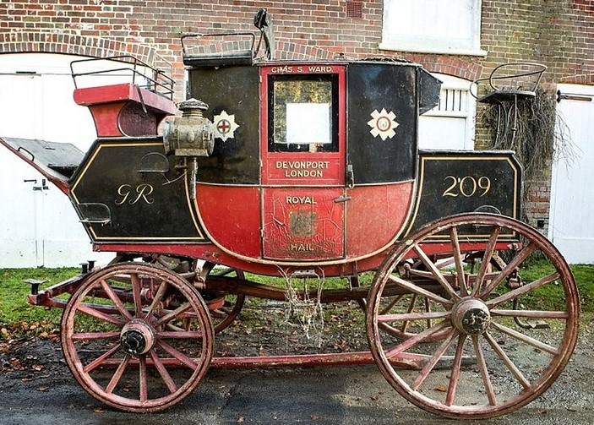
THE QUICKSILVER MAIL: 1820 – 1832
The Royal Mail Coaches were the express coaches of their day from London to Devonport via Yeovil, Haselbury Plucknett, Crewkerne, Chard and Exeter. The Quicksilver became the fastest ever Royal Mail Coach, covering the ground at an average speed of just over 10mph. This included stops for fresh horses at staging posts, new Guards and Coachmen and delivering the Royal Mail at the main Post Offices along the route. The Royal Mail Coaches established an almost legendary status amongst the public, town clocks were set by the arrival of the Mail Coach, Guards would be fined by the Post Office if the Coach was a minute late. People flocked to see the Royal Mail Coach as it passed.
In one famous incident the horses pulling the Quicksilver were attacked by a Lion that had escaped from a local zoo.
The Quicksilver Mail number 209 was the only named Royal Mail Coach. The coach arrived at the George Hotel at 10.12am each morning.
The Quicksilver, one of only two remaining Royal Mail Coaches, was sold by Bonhams to a private collector for £133,660 in December 2015
(Photograph: Bonhams)

