CIRCULAR WALK WEST OF TOWN
Distance: 2 miles
Time: 1 ½ hours
Description: Moderate/difficult walk along country paths and lanes with 2 steep slopes & 5 stiles.
Can be very muddy, especially after rain.
Start/End: Market Square
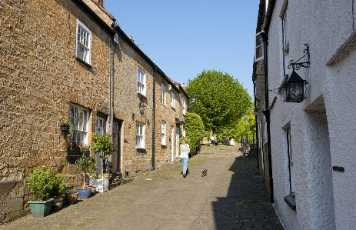
With your back to the Town Hall leave Market Square via Church Street on the right. Climb the steps to the churchyard. Exit churchyard through gateway in the wall at the far side of the church. Pass between the bollards and down the steps onto the pathway.
Note the renowned west front of the church
At the end of the pathway walk straight ahead between the farm buildings along a narrow (usually muddy) footpath through the iron kissing gate into Bincombe Valley.
Continue up the valley through the iron farm gate in the fence following the path to the step through stile at the top of the valley.
It is worth looking back at the stunning view of the town and beyond
Cross the cart track and continue straight ahead into the sunken lane. When the lane reaches a concrete driveway turn right through a wooden gate and follow it down towards the farm buildings. Where the driveway bears left leave the road and continue straight ahead and through the metal gate into the field beyond.
Continue straight ahead following the footpath across the field and through a small wooden gate. Cross the second field keeping to the left, and over the stile to the right of a metal gate into sunken lane.
Continue along the lane until it joins the roadway. Turn left and walk along the road until it turns sharp left. Leave the road and take the footpath on the right with the signpost ‘Hinton Road 1/3rd mile’.
Walk up the steep sunken footpath and over the stile at the top. Continue straight ahead across the field and at the top of the slope bear right towards a metal gate at the corner. Cross the stile to the left of the gate and turn right into the lane. After 30 yards the lane enters Hinton Road. Turn left along the road and after 50 yards take the footpath on the left sign posted ‘Crow Castle Lane ¼ mile’.
Follow the footpath down the slope and over the stile. Continue along the sunken footpath. Where it joins the cart track turn left into sunken footpath. At the bottom of the slope leave the path and turn right through the rambler gate into the field.
Straight ahead across the field and through rambler gate in hedge. Follow the footpath onto the Hinton Road.
Turn left and walk down the hill into Abbey Street.
Take note of the Victorian Cottages on your left, Poples Well on your right and St Bartholomew’s Church Hall (formerly Crewkerne Grammar School – note the blue plaque)
Continue to Market Square behind the Town Hall.

